Data Science with Python: Project 4

By: Bhupendra Nirgun

Contents

1. Data acquisition of the movielens dataset : 3

2. Perform the Exploratory Data Analysis (EDA) for the users dataset 4

Visualize user age distribution 4

Visualize overall rating by users 5

Find and visualize the user rating of the movie “Toy Story” 6

Find and visualize the viewership of the movie “Toy Story” by age group 7

Find and visualize the top 25 movies by viewership rating 8

Find the rating for a particular user of user id = 2696 8

3. Perform machine learning on first 500 extracted records 9

4. Complete Code File 11

## Data acquisition of the movielens dataset :

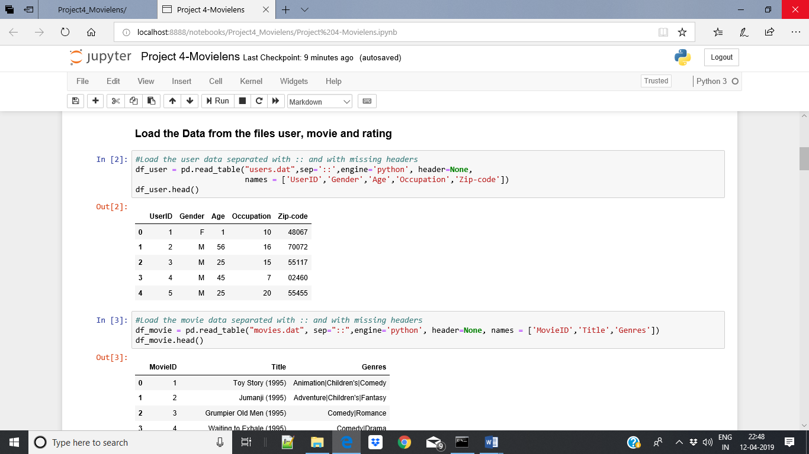

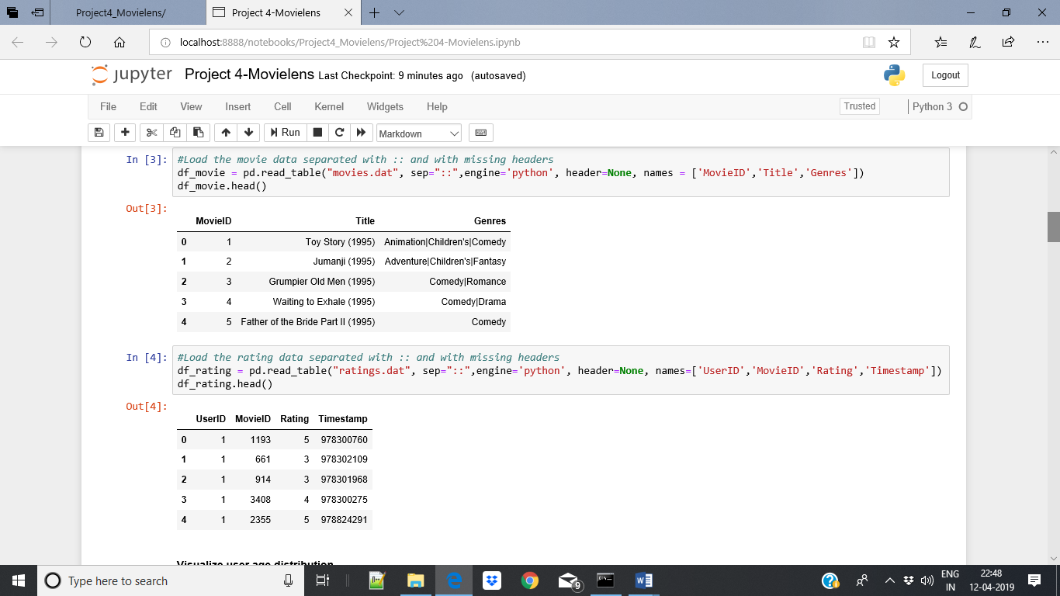

## Perform the Exploratory Data Analysis (EDA) for the users dataset

### Visualize user age distribution

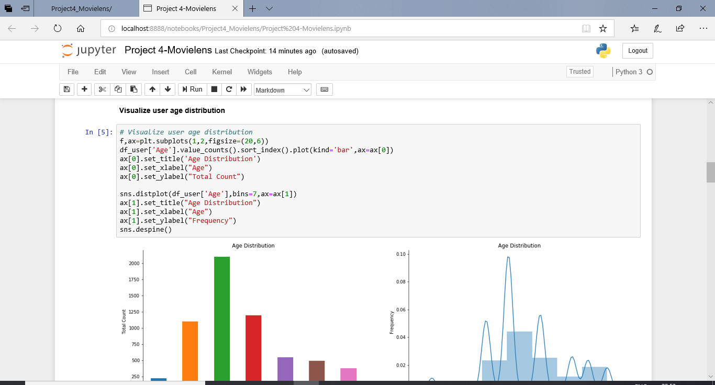

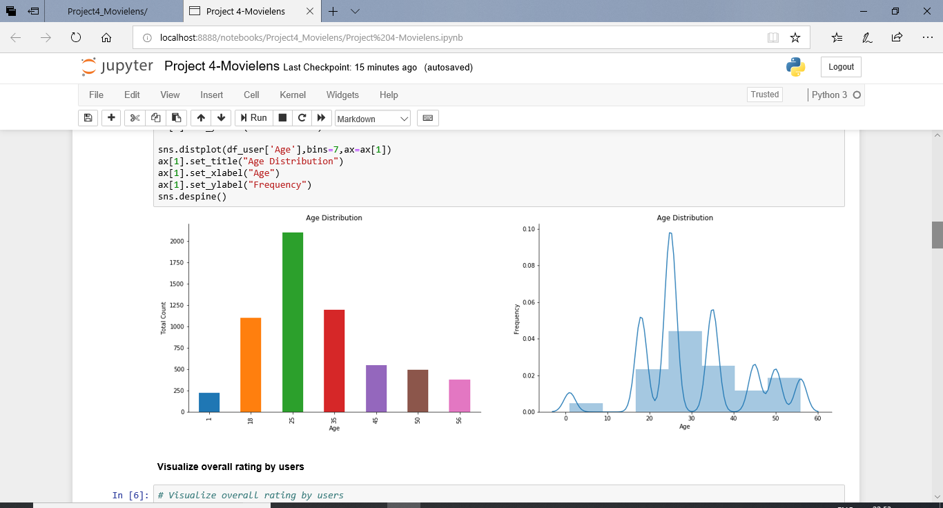

### Visualize overall rating by users

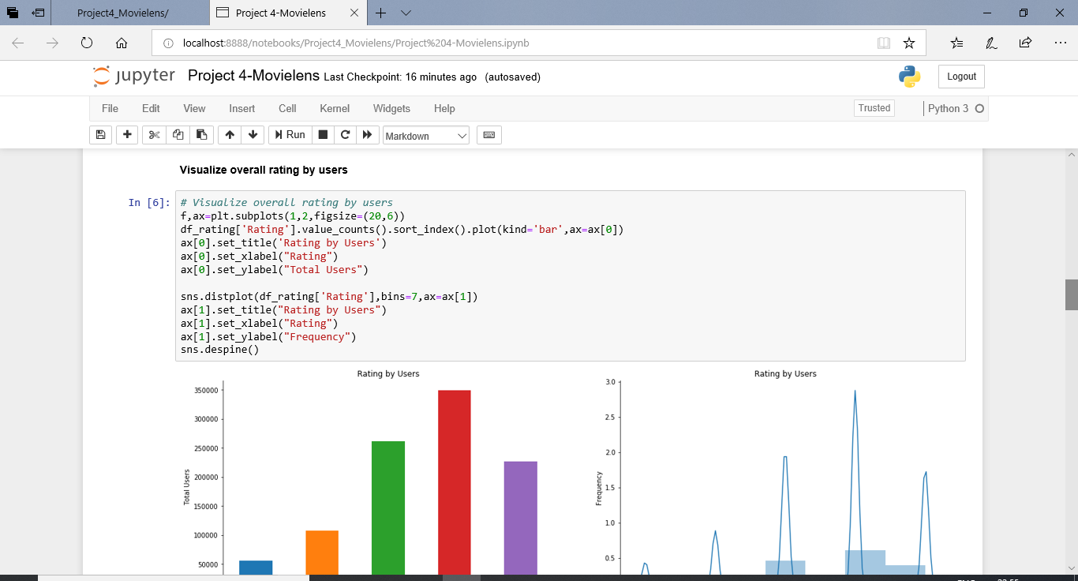

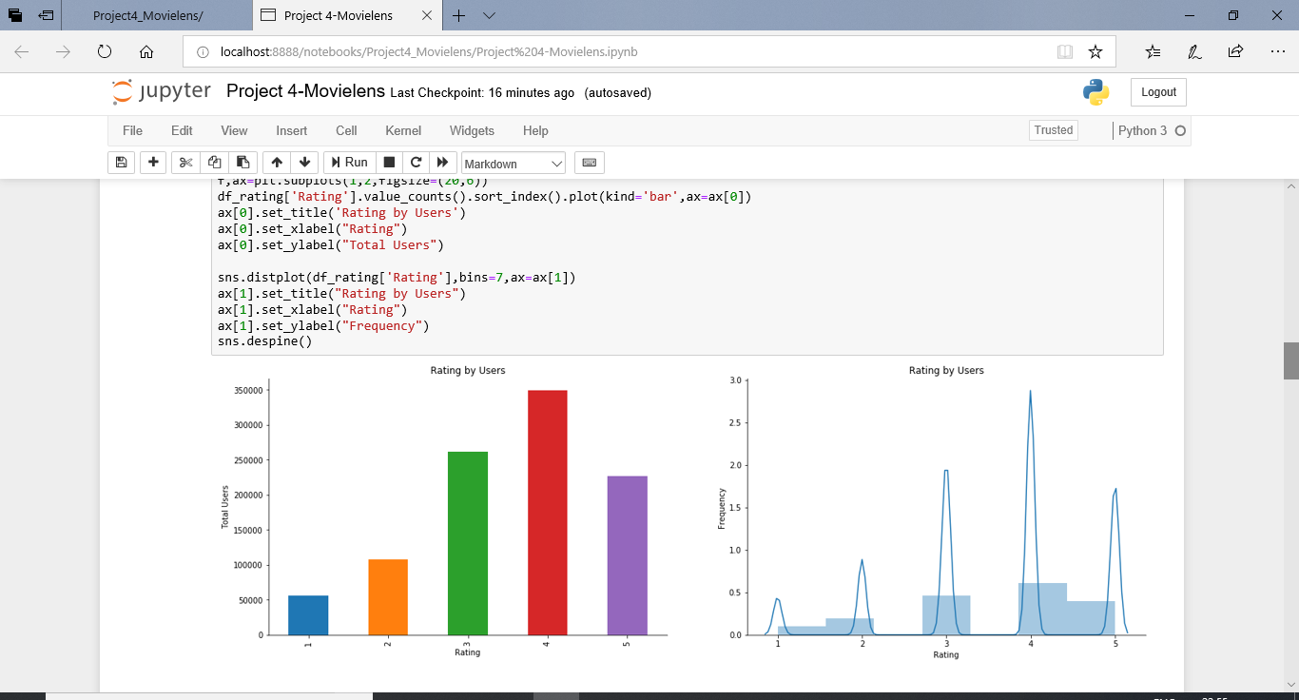

### Find and visualize the user rating of the movie “Toy Story”

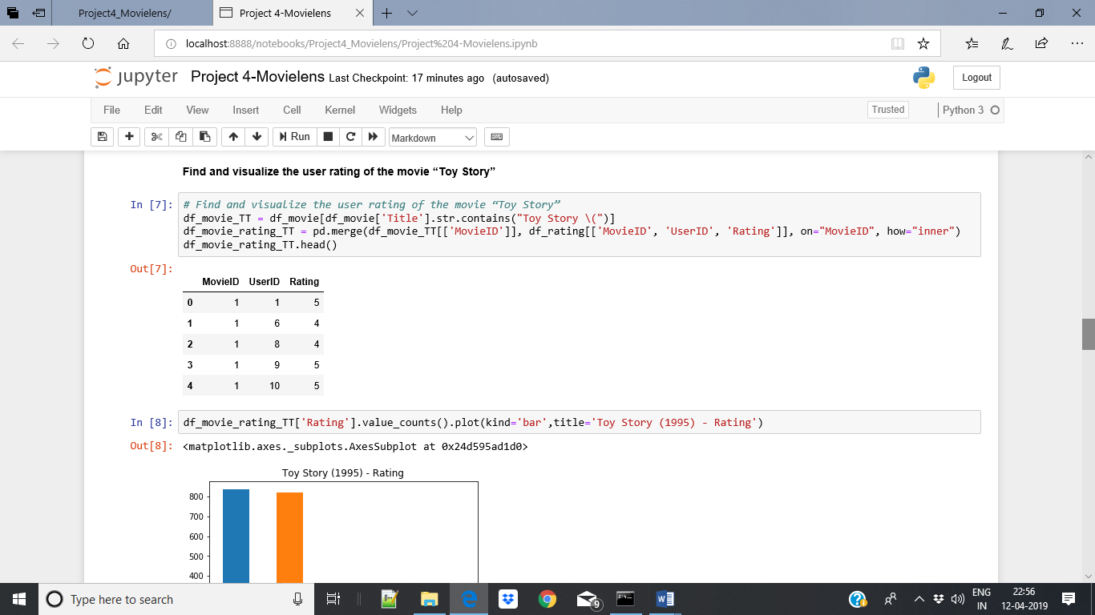

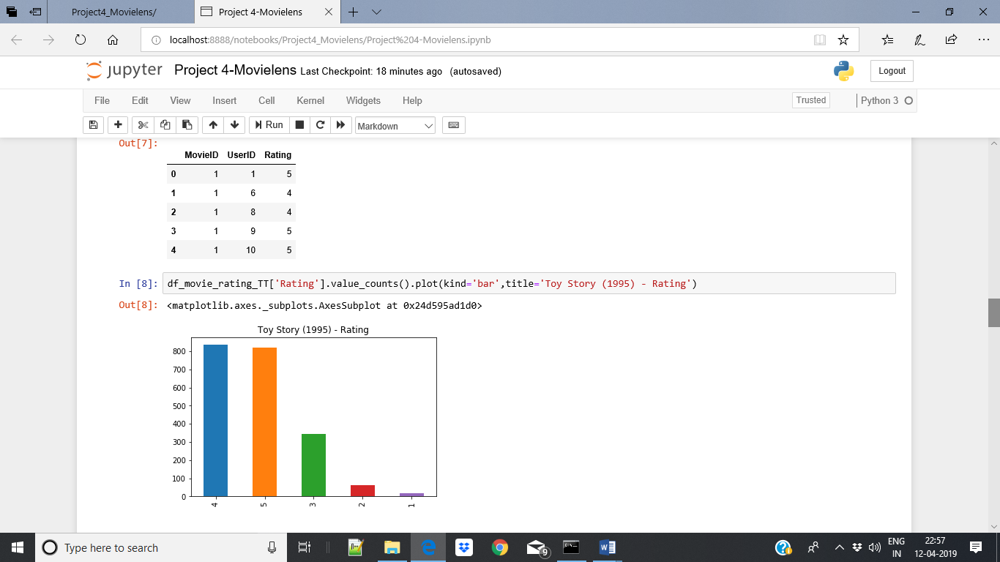

### Find and visualize the viewership of the movie “Toy Story” by age group

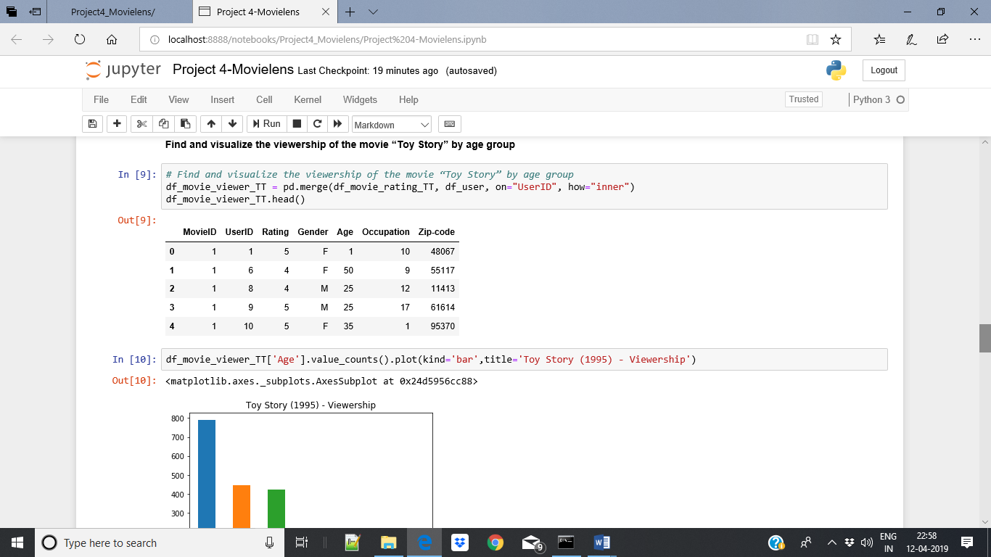

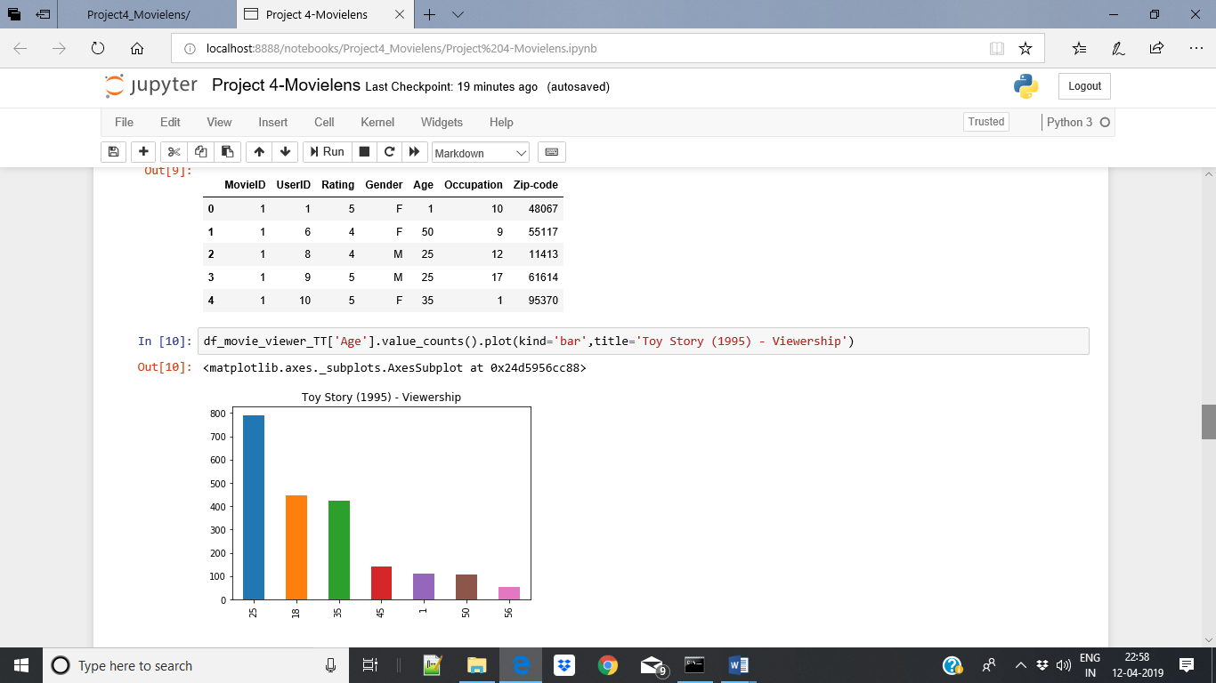

### Find and visualize the top 25 movies by viewership rating

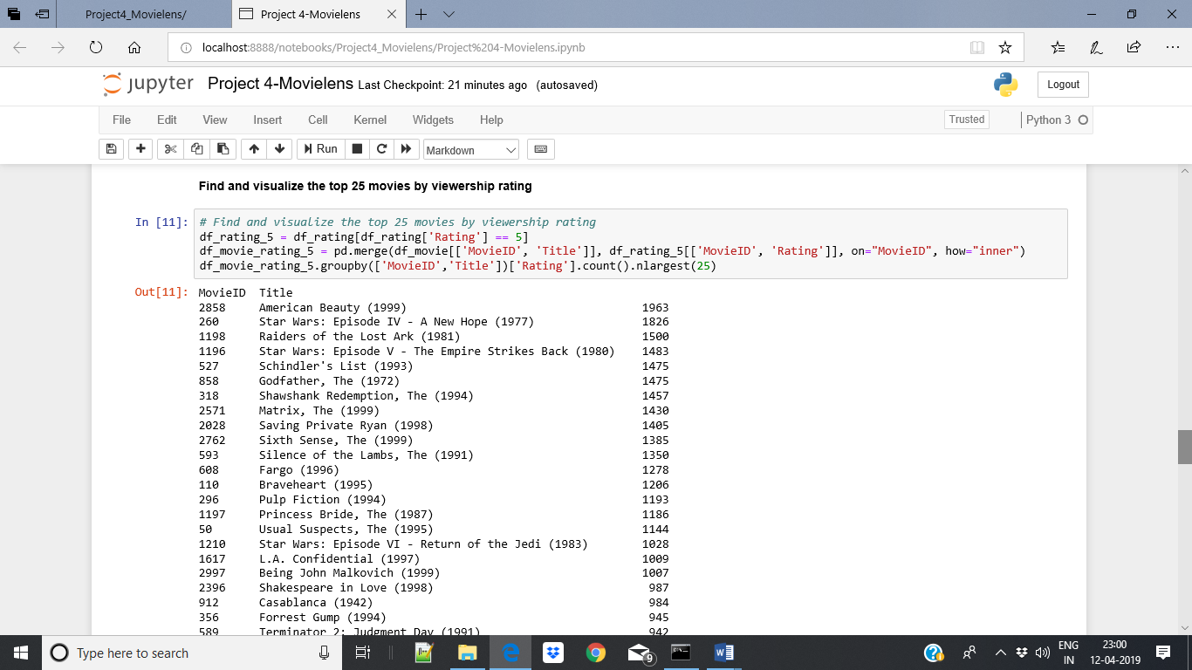

### Find the rating for a particular user of user id = 2696

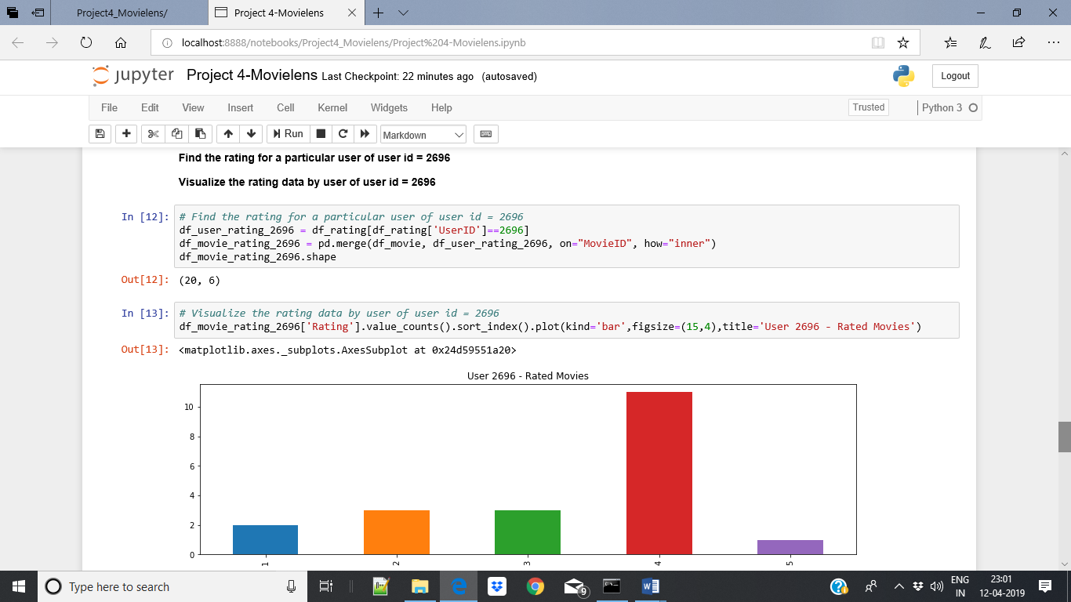

## Perform machine learning on first 500 extracted records

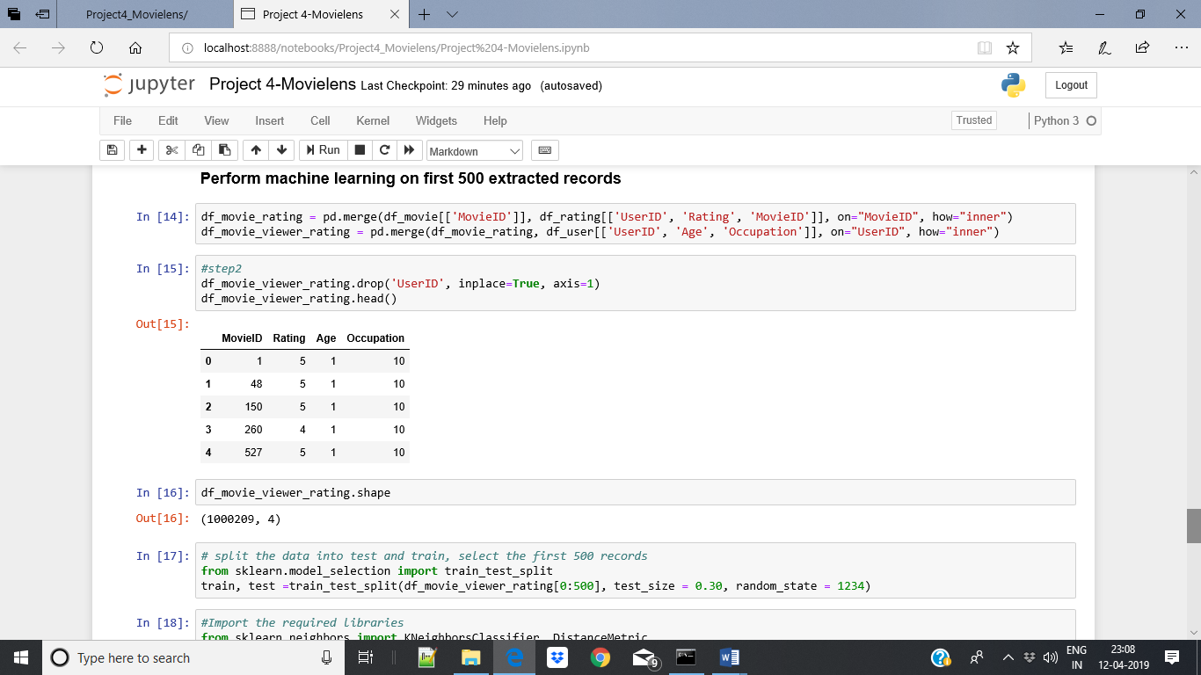

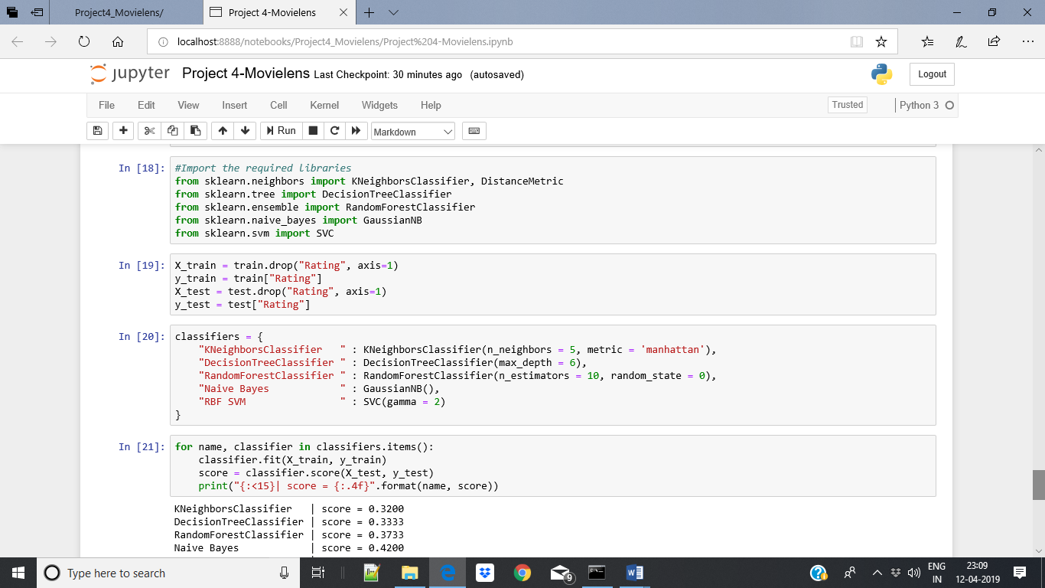

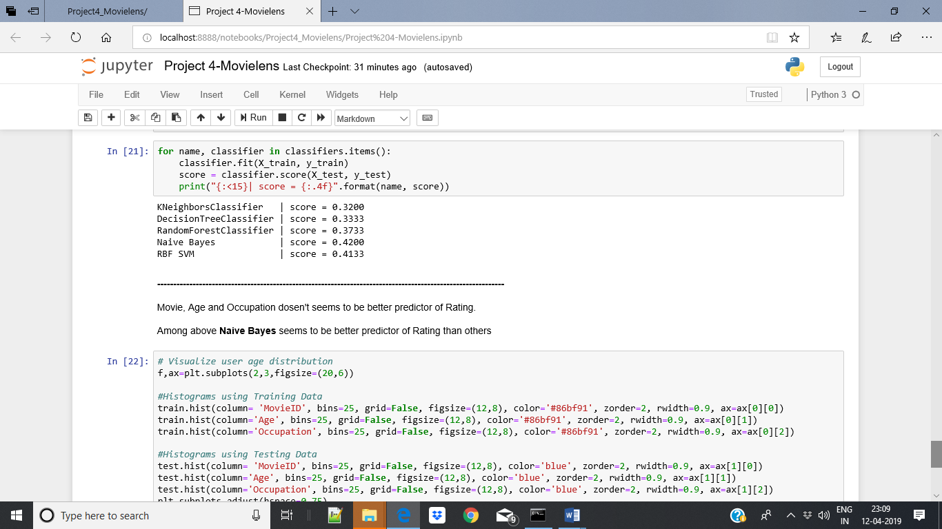

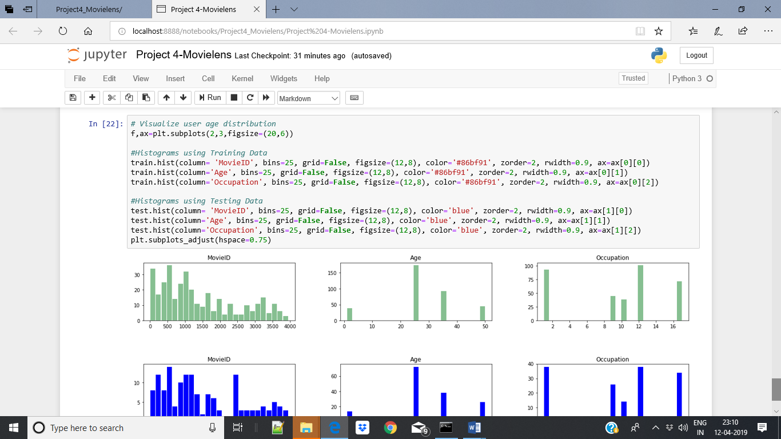

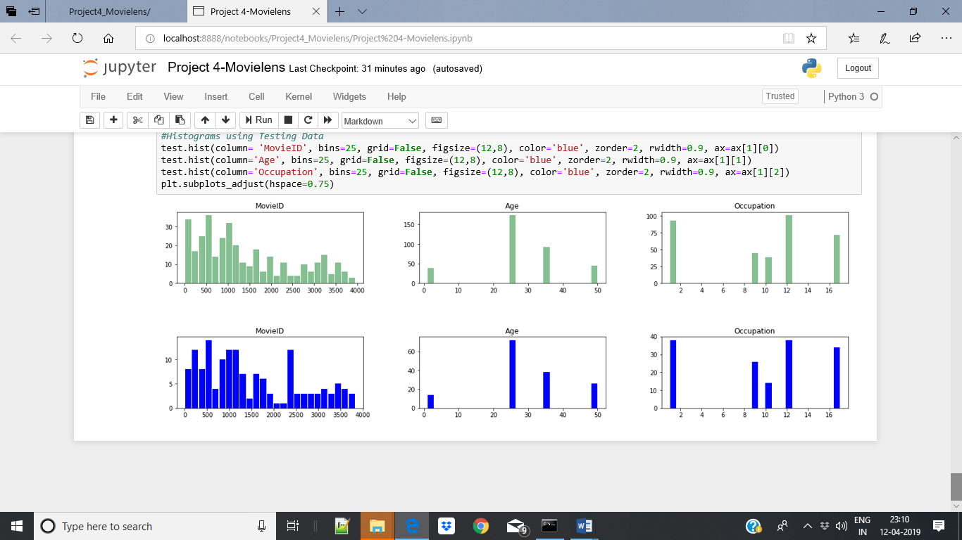

## Complete Code File

Below attached is the extract of code file.

